**Scrinshot Tampilan Program**

Yakup Abdullah / 155610071

Umbu Maramba Lundung / 155610067

Halaman Tampil Data Buku

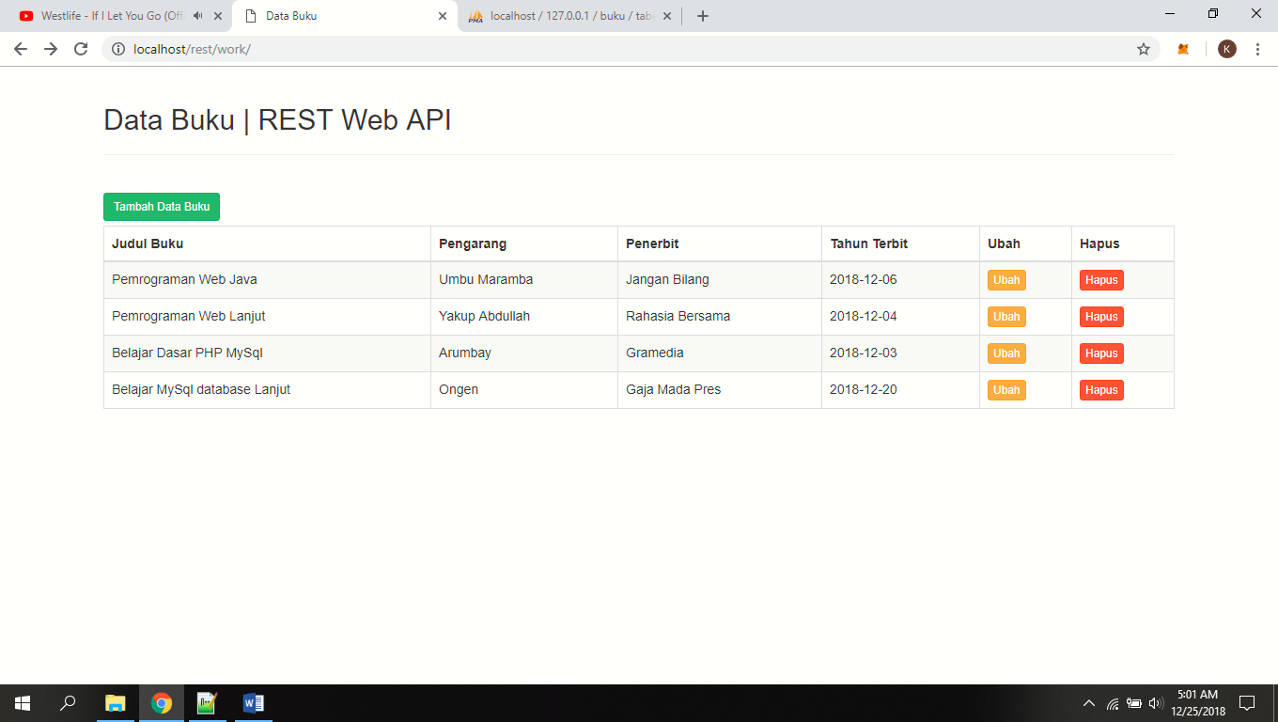

Tampilan Halaman Input Data

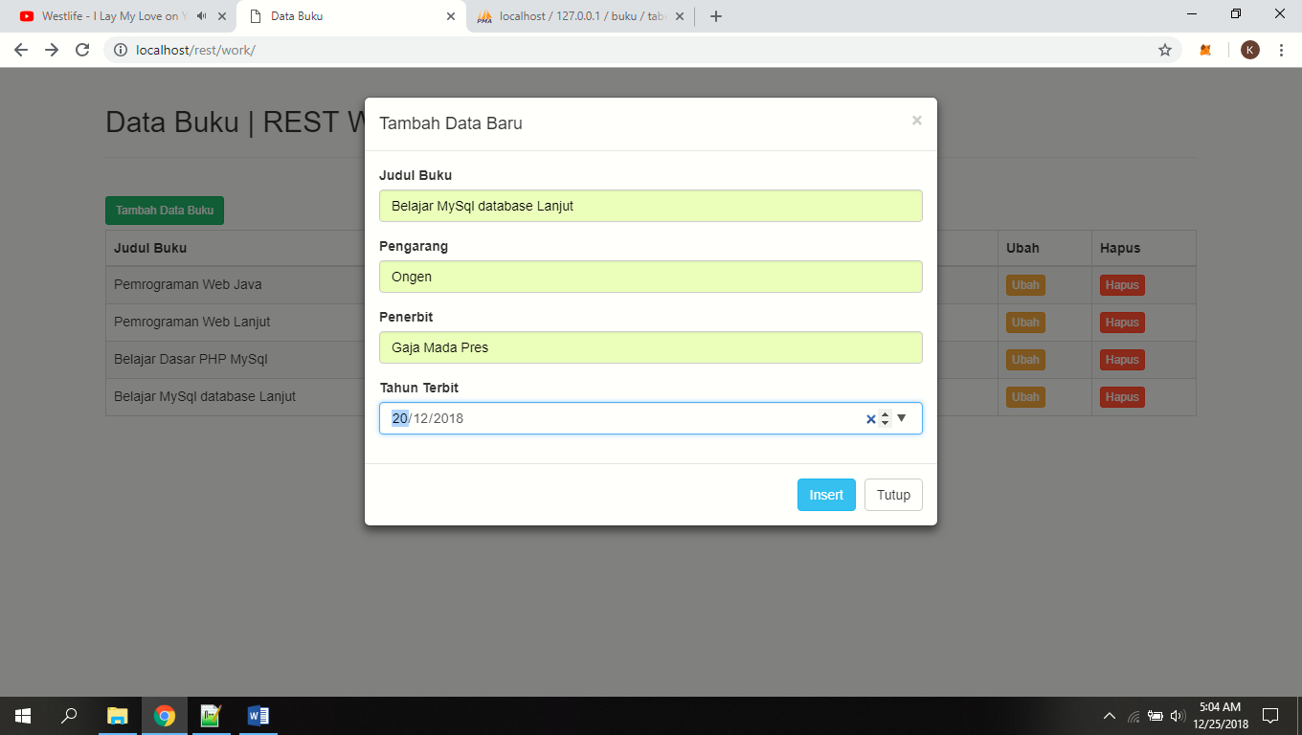

Tampilan Halaman Edit

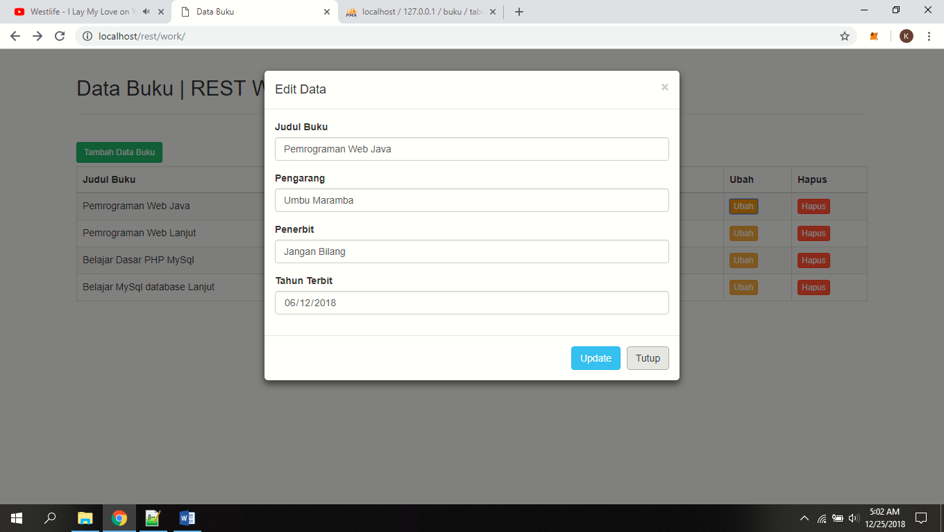

Tampilan Ketika Kita Klik Tombol Hapus

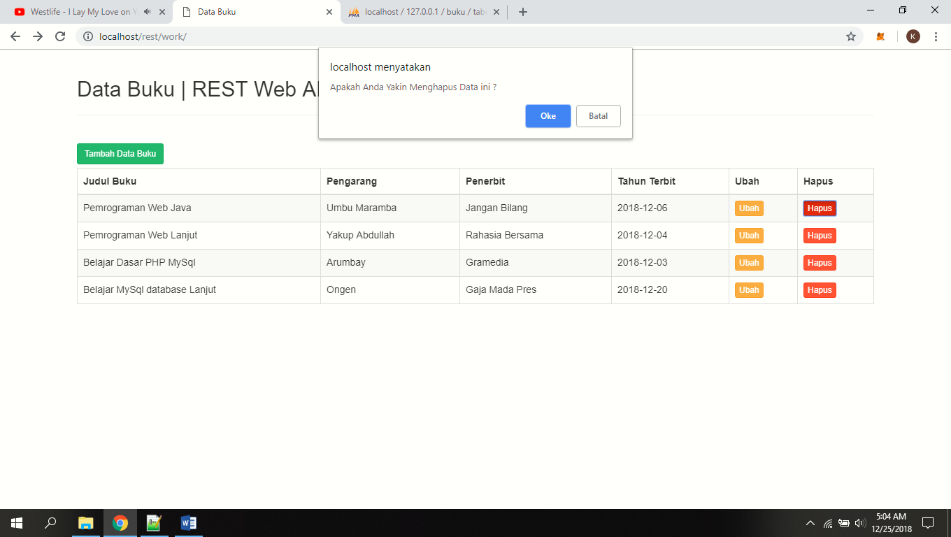

Struktur Tabel Database

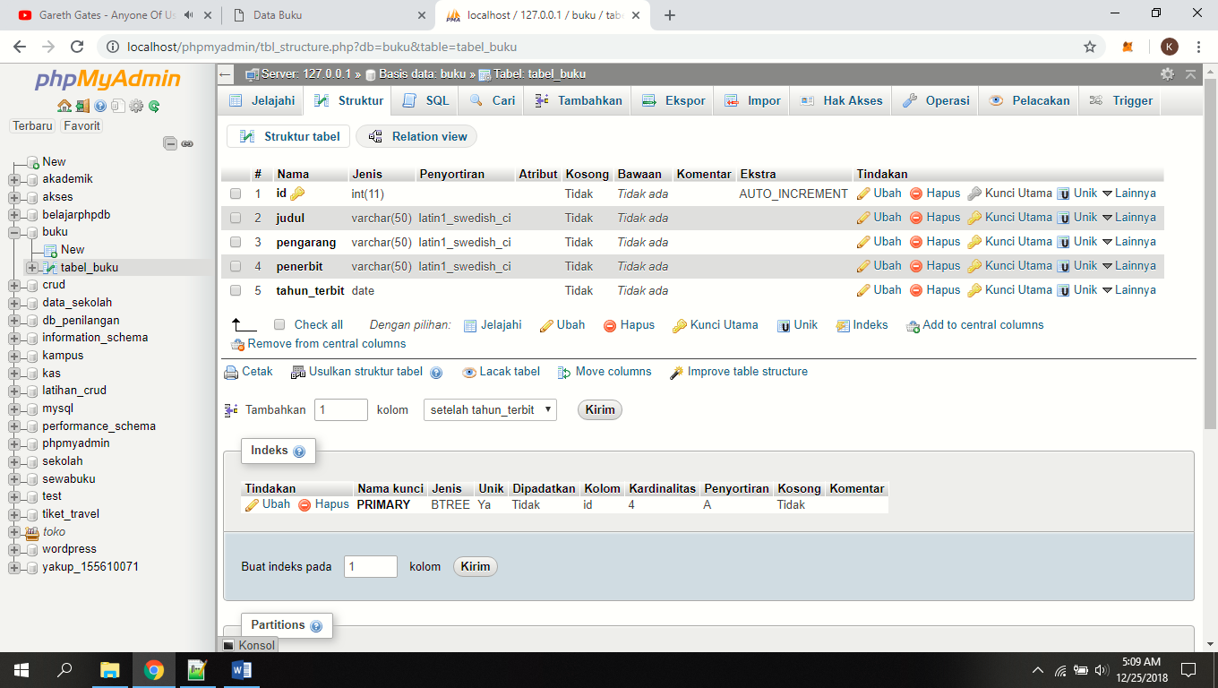

Data Yang Sudah Diinput

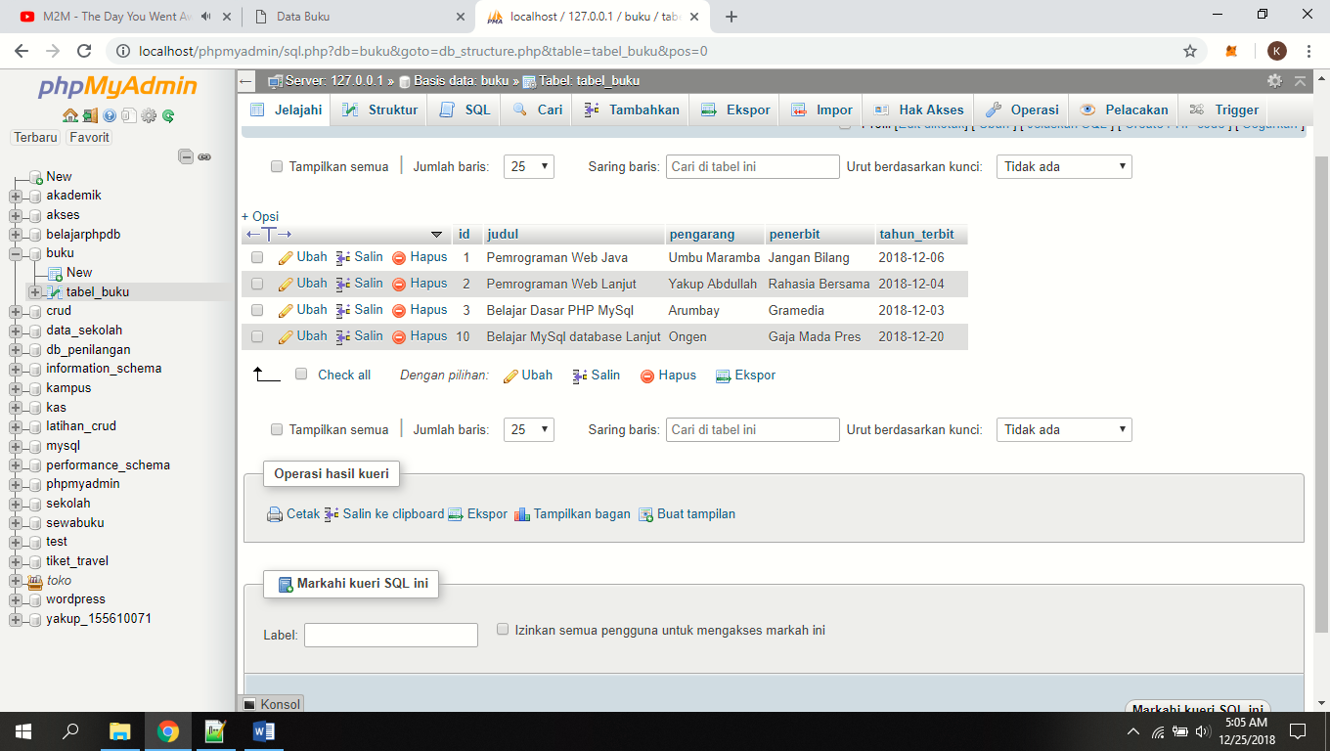

Sumber :

https://www.webslesson.info/2018/05/how-to-make-simple-crud-rest-api-in-php-with-mysql.html